**Big data**

It is used to handle large datasets.It can handle structured as well as unstructured data.

**Local vs distributed system**

Big data cannot be stored on a single node or machine.It needs multiple nodes to process the data.

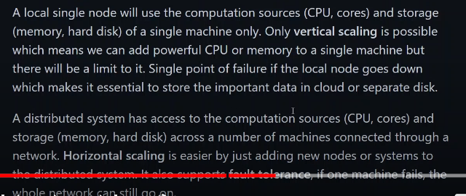

**Distributed system architecture**

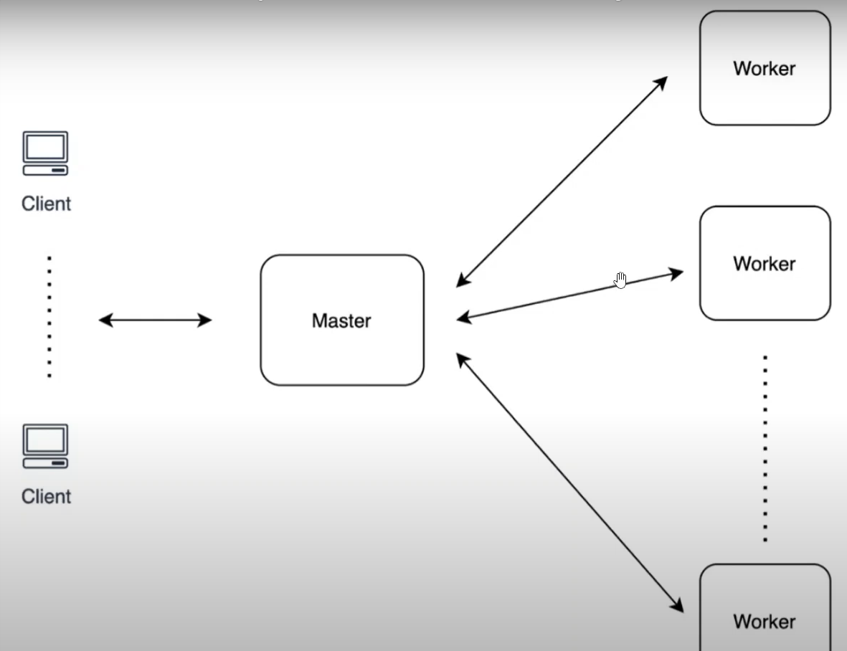 in a distributed system architecture there is a master node.the client request comes to the master nodes to do a particular task.

* The master node will have further worker nodes underneath it.
* The worker nodes will distribute the work amongst them.
* Sometime it may happen that the master goes down then the worker will go up an d become master and when the master is up the worker node will loose its job.

**Apache Hadoop and map reduce**

Apache Hadoop is a collection of open source utilities that facilitate using a network o fmany compuiters to solve the issues with massive data and computation.

**HDFS:** Hadoop has hdfs which si a portable sclable and distributed file system which is written in java for Hadoop framework and allows users to work with large datasets.

**Mapreduce**

Hdfs uses mapreduce which allows computation on that data.

**Fault tolerance**

Hdfs uses blcoks of data for fault tolerance as it replicates the blocks of data on the slave nodes.

**MapReduce**

Map reduce is a way of splitting a computational task to distributed set of files sucha s HDFS.

It has a **job tracker** at master node and multiple task tracker at the slave nodes

**Job tracke**r send code to run on the **task tracker**.The task tracker allocates cpu and memory for the tasks and monitor the tasks on the worker nodes.

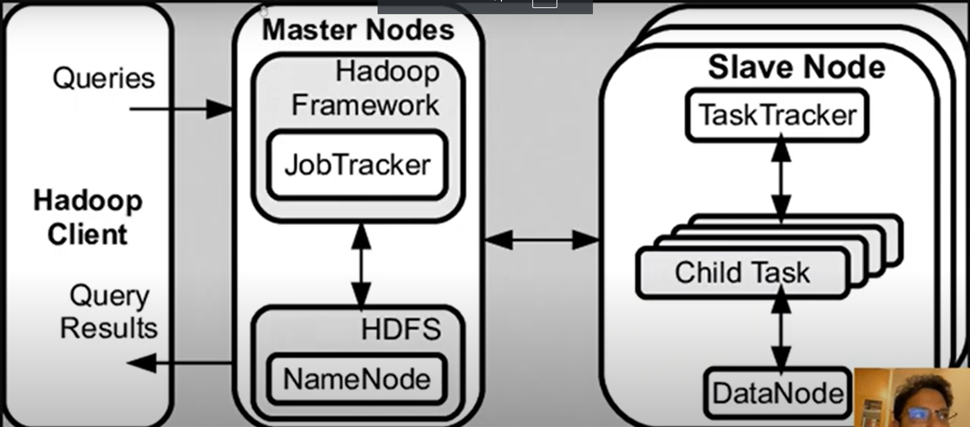

**Apache spark**

Apache spark is a multi language engine for executing data engineering data science and machine learning on single node machine or cluster

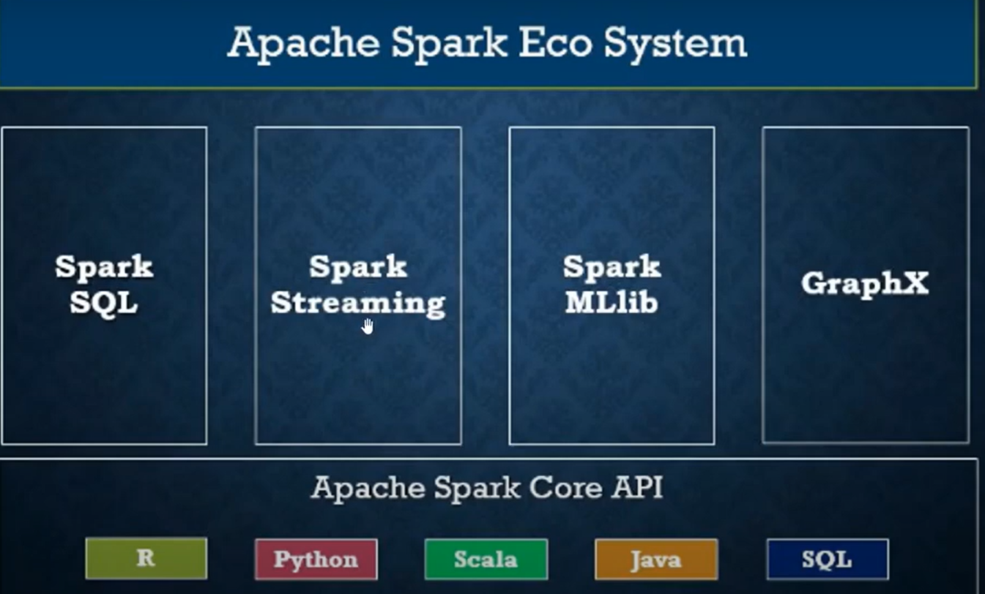

**Key features**

1. Spark does sql analytics using the rdd and spark sql.

It executes fast,distributed ANSI SQL queries fpr dashboards and adhoc reporting.It runs faster than most data warehouses.

2.Machinse earning using SparkML

Train machine learning algorithms on a laptop and use the same code to scale to fault tolerant clusters of thousands of machines.

1. Atch/streaming data using the spark streaming

Unify the processing of data in batches and real-time streaming.

**WHY DO WE NEED SPARK WHEN WE ALREADY HAVE TH EHADOOP ECOSYSTEM**

Spark was a flexible alternative to MapReduce

|  |  |
| --- | --- |
| MapReduce | Spark |
| Mapreducecan store the data only in hdfs | but sark can store in aws,hdfs,Cassandra,hbase |
| MapReduce writes most of the data to the disk after each map and reduce exeecution | Spark does operation 100x faster as it only use in memory and store there.Spark only stores to the disk when its memory is full |
|  |  |
|  |  |

, **CLUSTER MODE OVERVIEW**

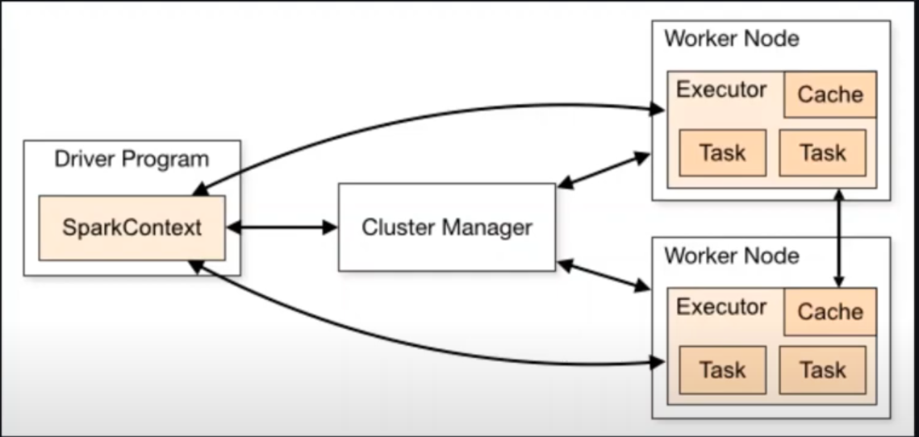

**Spark** applications run as independent set of processes on a cluster

**Cluster**  as can be seen above there is a cluster having several worker nodes.

**Spark context:** all the processes ona cluster are coordinated by the spark context.this is our main program also called the driver program.Spark context takes hold of all the worker nodes,executors and executor tasks.Spark contex send the tasks to the executor to run.

**Cluster manager:** to work on a cluster the spark needs a cluster manager

Example of cluste rmnaager are:YARN,Kubernetes.AWS EMR (elastic map reduce ) is the most widely used cluster manager

So the job of a cluster manager is to allocate resources across applications.

The resourcesa re allocated to the worker nodes by the cluster manager on the request of the spark context.

**Explanation:** spark applications run as independent sets of processes ona cluster coordinated by the spark context object on our main program (called the driver program)

Specicfcally to run on a cluster the sparkcontext can connect to several types of cluster manager(either sparks own cluster manager,yarn,kuberneets)) which allocate resources across applications.

Once connected Spark acquires executors on nodes in the cluster which are processes that run computations and store data for our application.

Next it sends our applcition code(defined by jar and python files passed to the spark context)to the executors.

Finally spark context send task to task executors.

**Summary:**

1. Spark context is the main program
2. It connects to the cluster managers who allocate resources to the slave nodes.
3. Spark context on connection with the worker node acquires the **(which process and store the data )**
4. Now spark send the application coed to the executor
5. Then spark gives the tasks to the worker nodes.

**INTERNALS OF JOB EXECUTION**

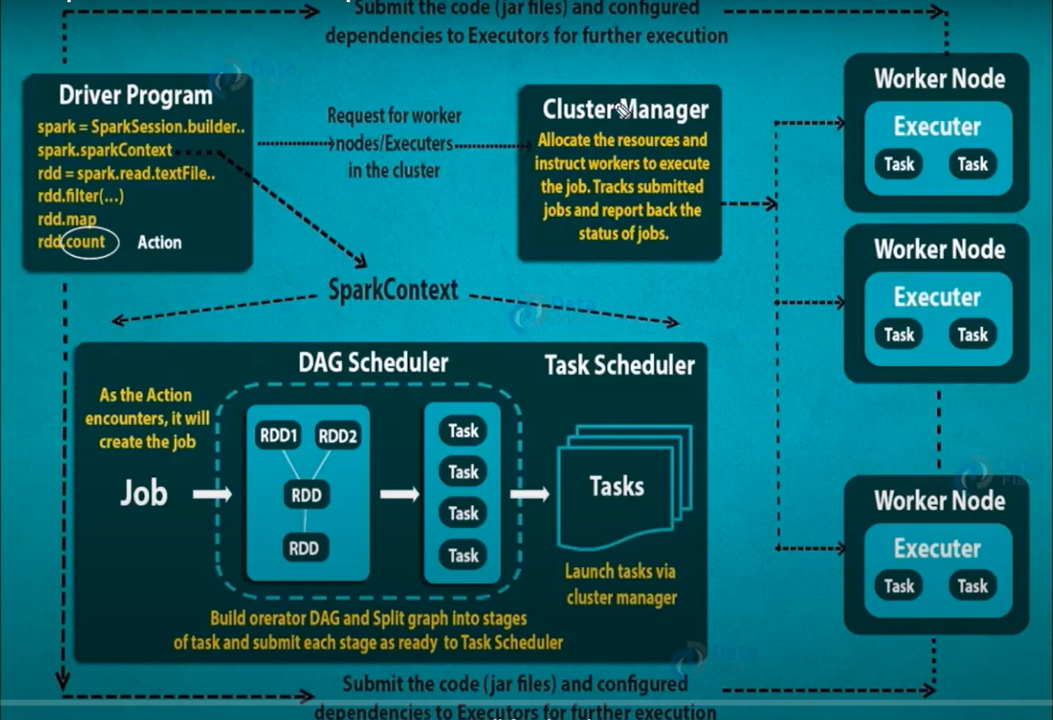

SPARK  **RDD OVERVIEW**

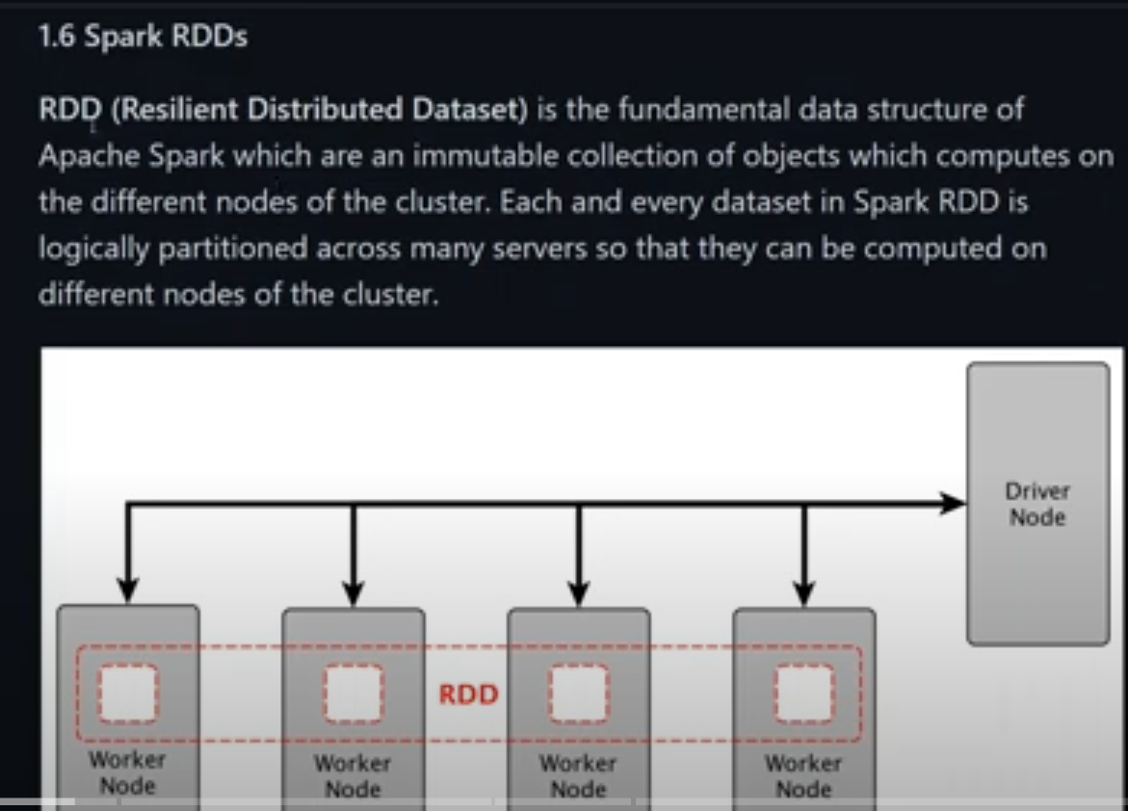

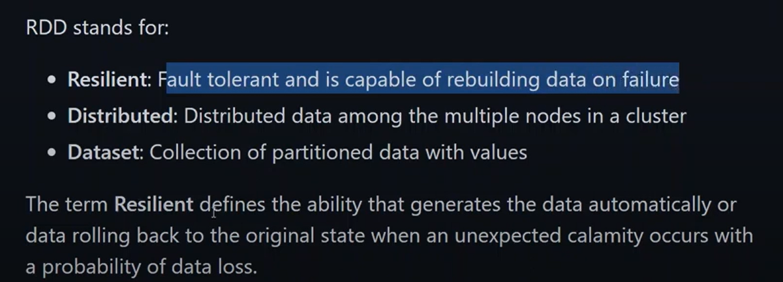

**MAIN FEATURES OF RDD**

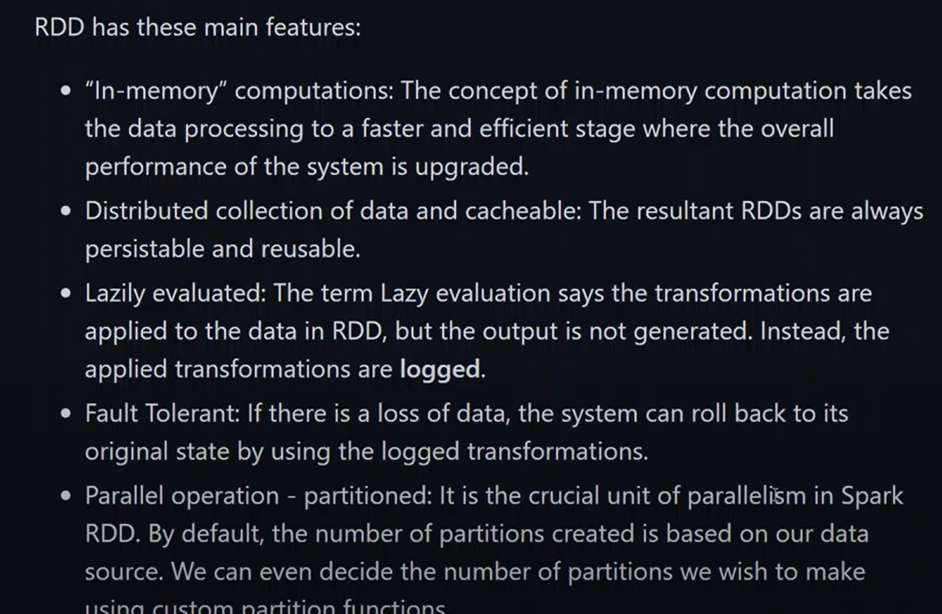

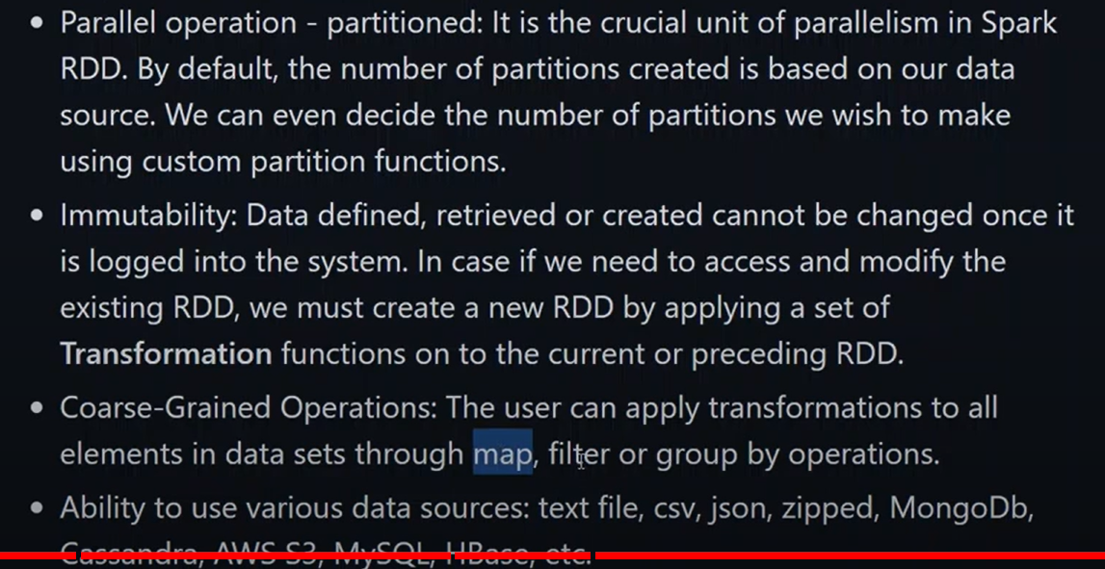

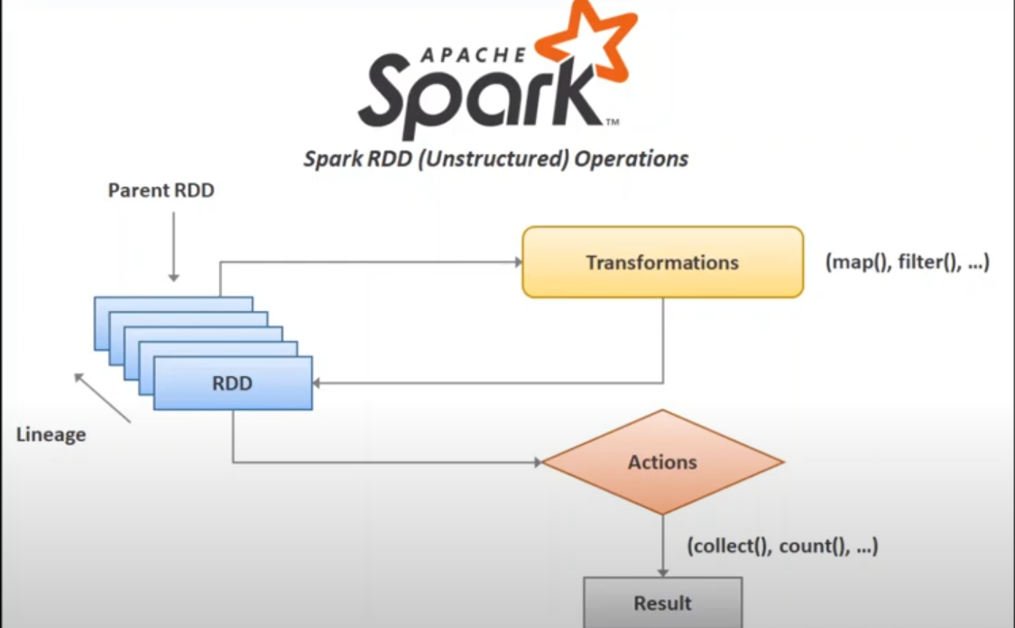

**RDD OPERATIONS**

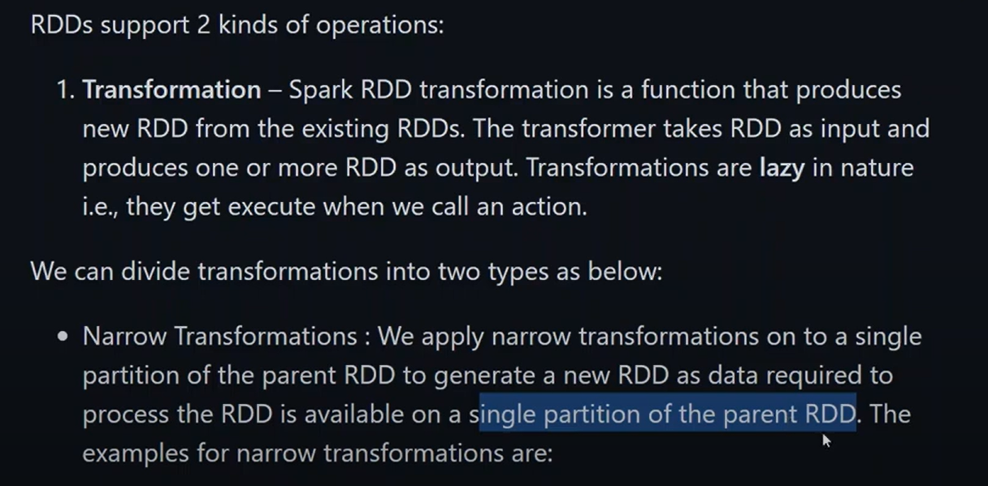

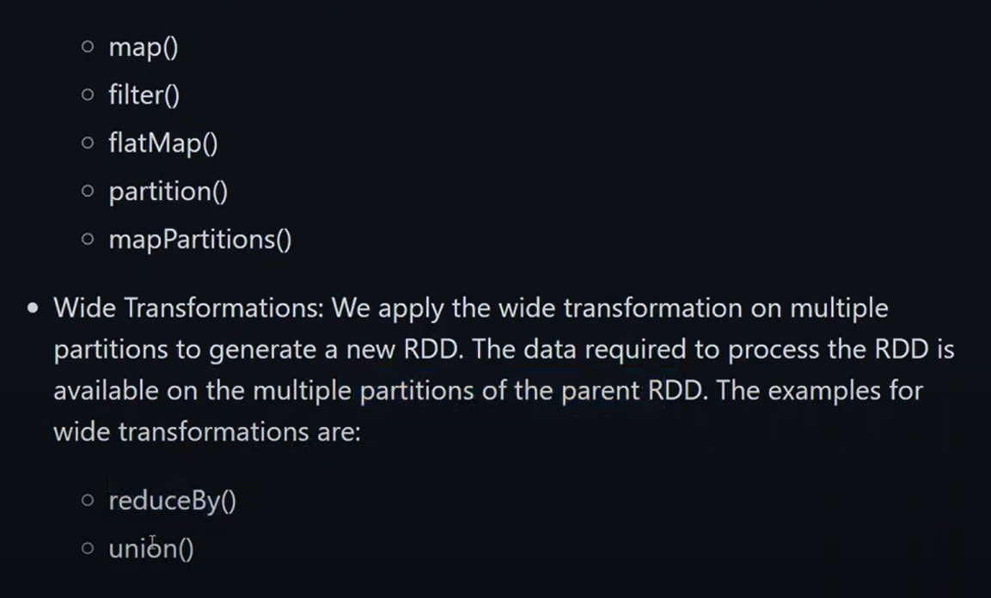

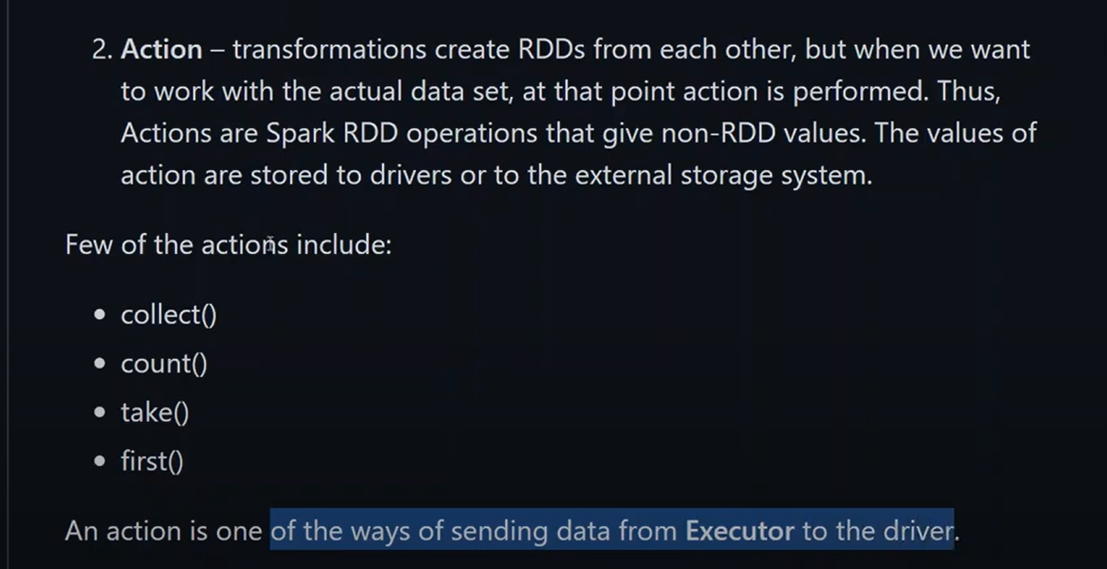

**INSTALLATION**

We ned to install jdk,scala,intellij and maven onto our system

After that install apache spark and Hadoop

Set the spark home and Hadoop home environment variable

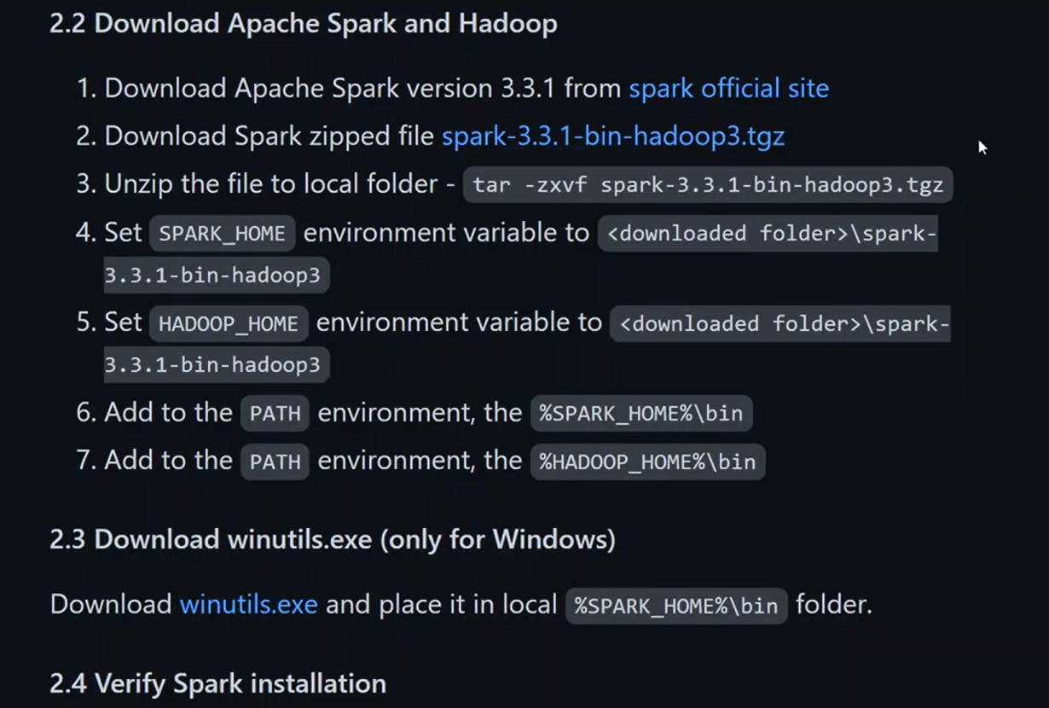

Set the Hadoop home and spark home environment variable

**VERIFY SPARK INSTALLATION**

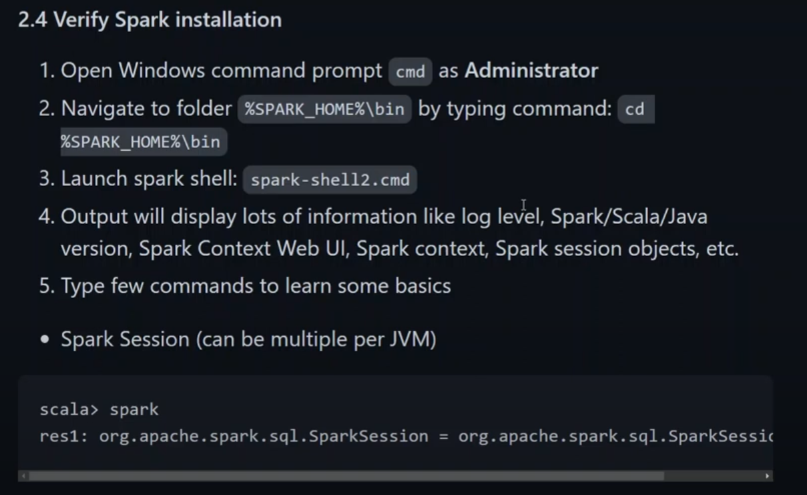

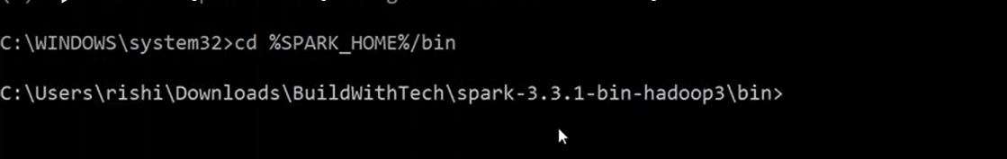

Now here we need to install the spark shell so that we can continue on our work

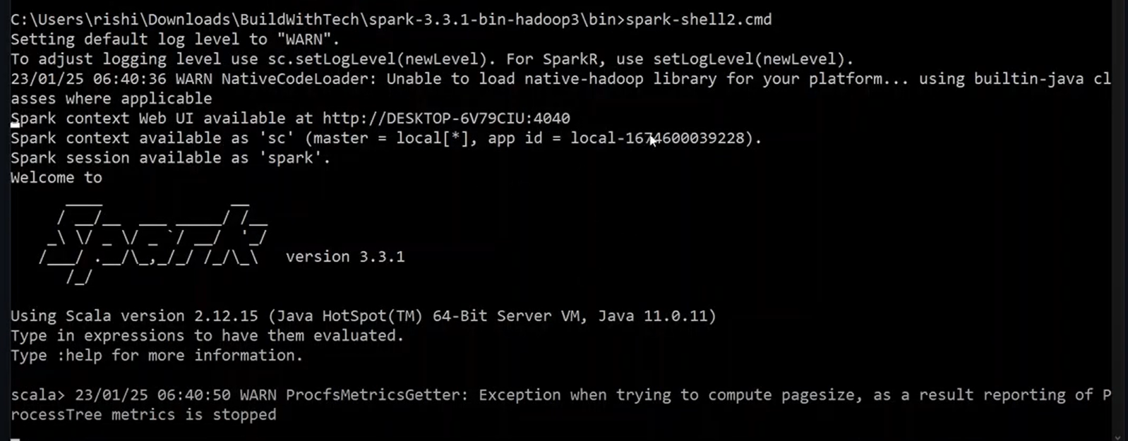

Spark context is 1 per jvm

Spark session can be multiple

Now when we do enter the spark shell now we will be entering the spark shell.

Now we will be doing the spark commands.

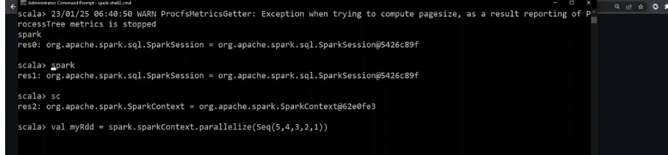

We will be making a spark session and now we will be creating a spark context object and work on it.we made an rdd as seen above.

**Now we will print each rdd**

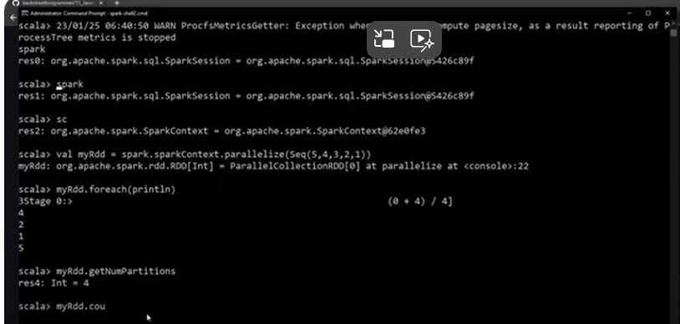

**Intellij project maven and java**

1. Create a new maven project
2. 2. Ow we will be adding the dependencies to it.

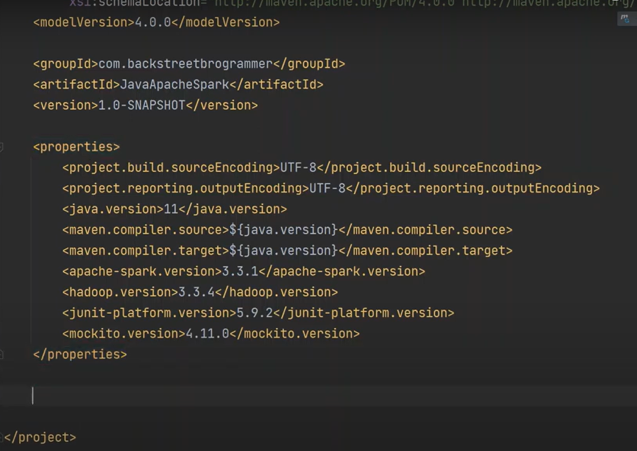

3.

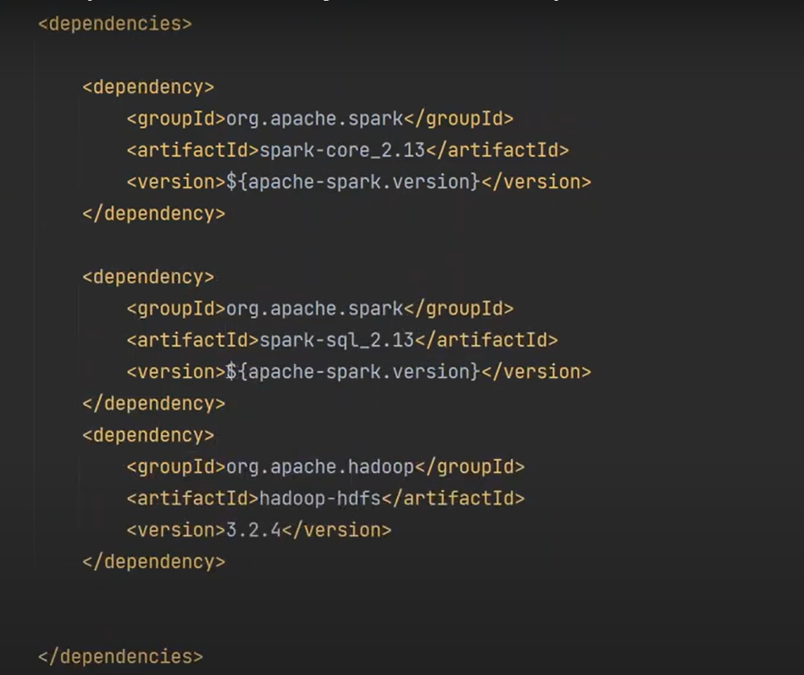

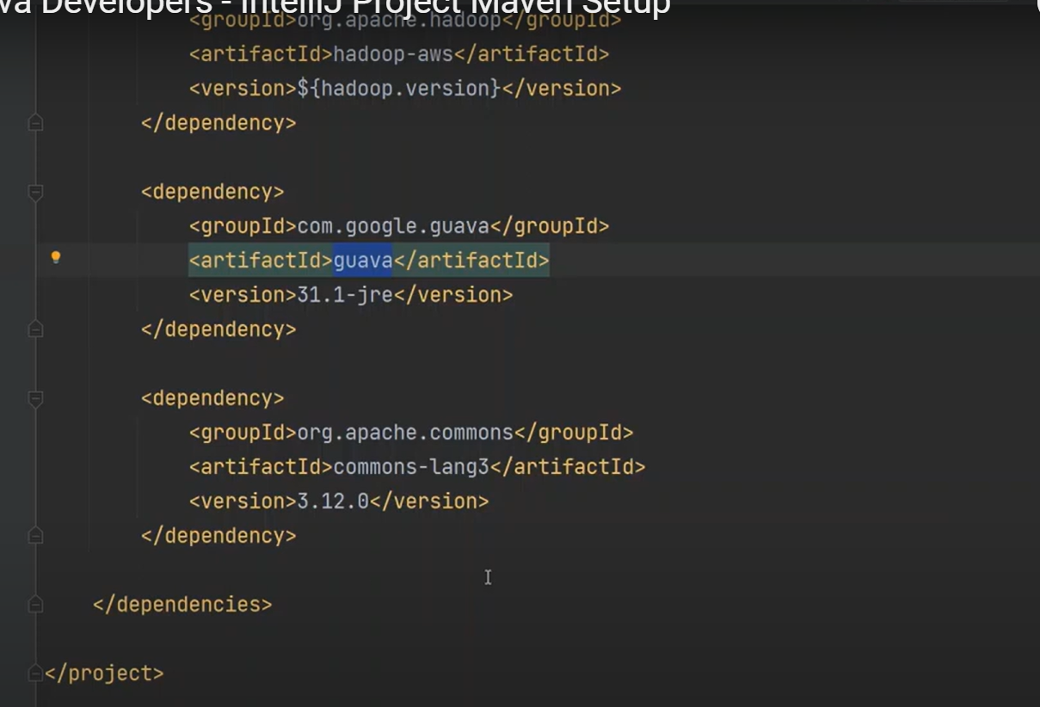

Also add a maven compiler plugin 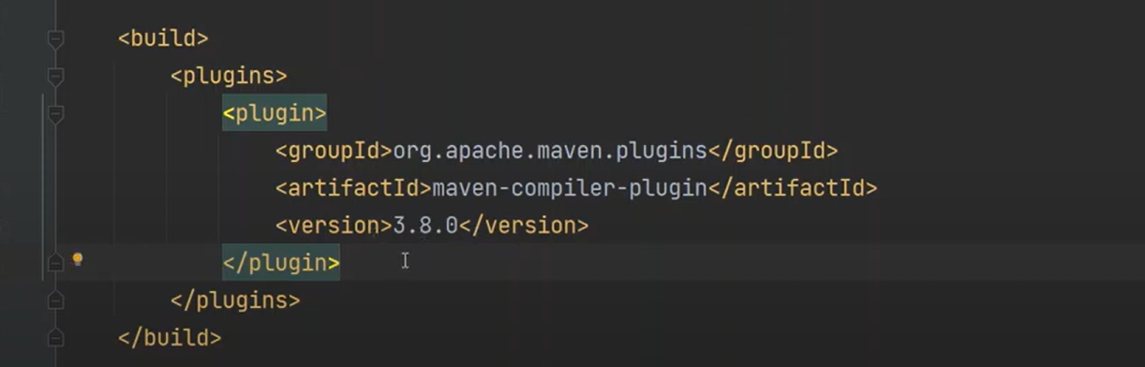

**Spark context**

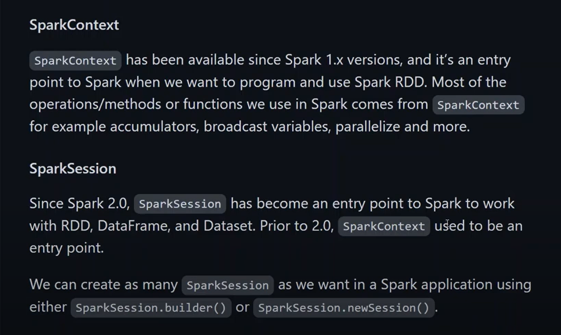

**Spark first program**

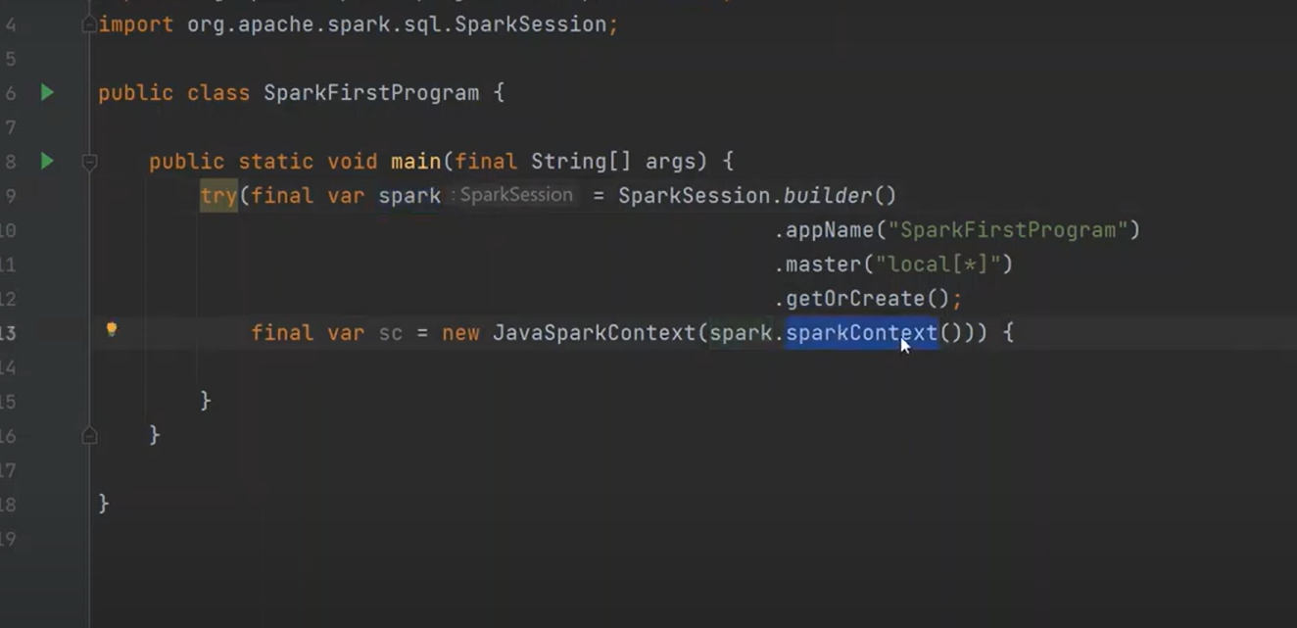

**Spark session**

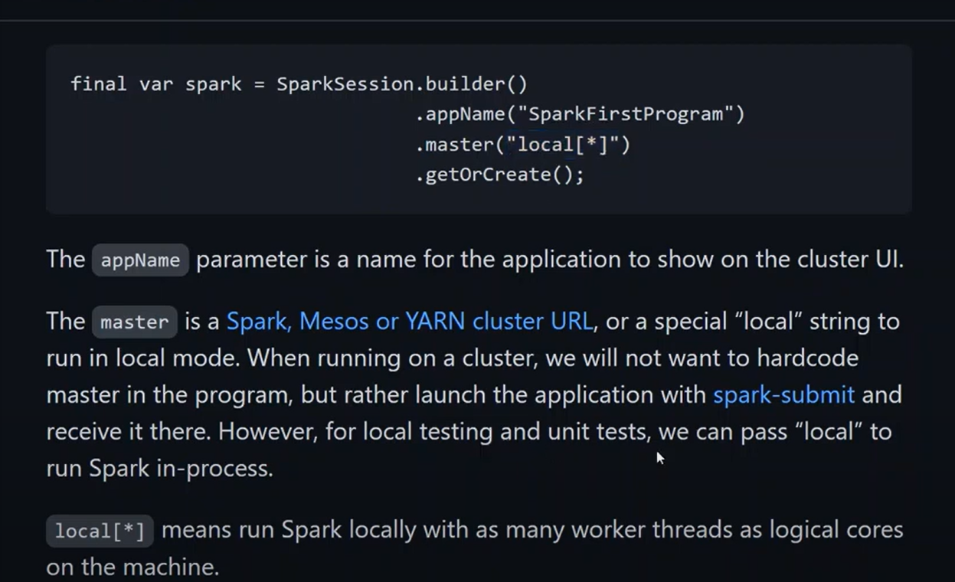

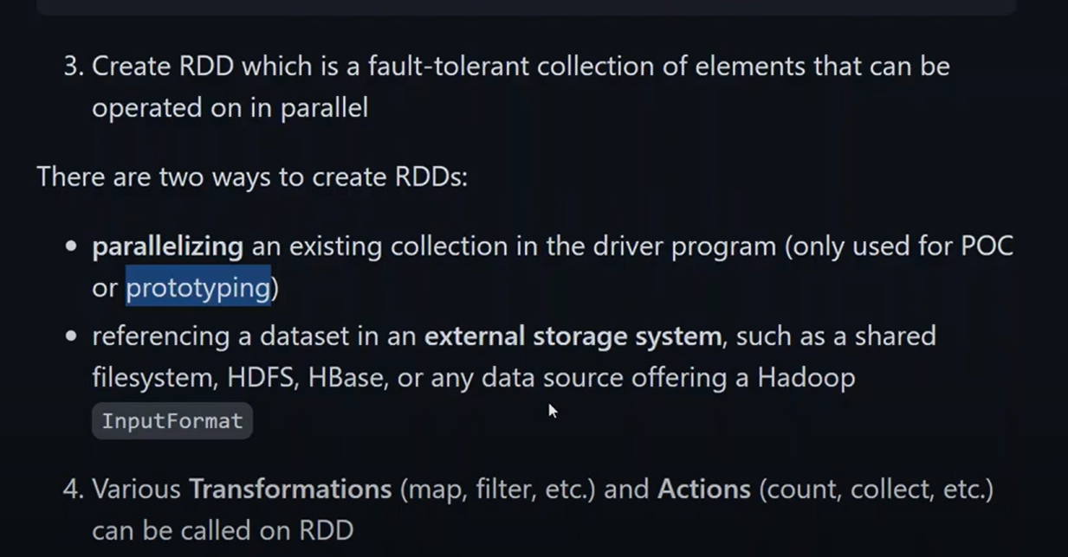

**SPARK FIRST PROGRAM**

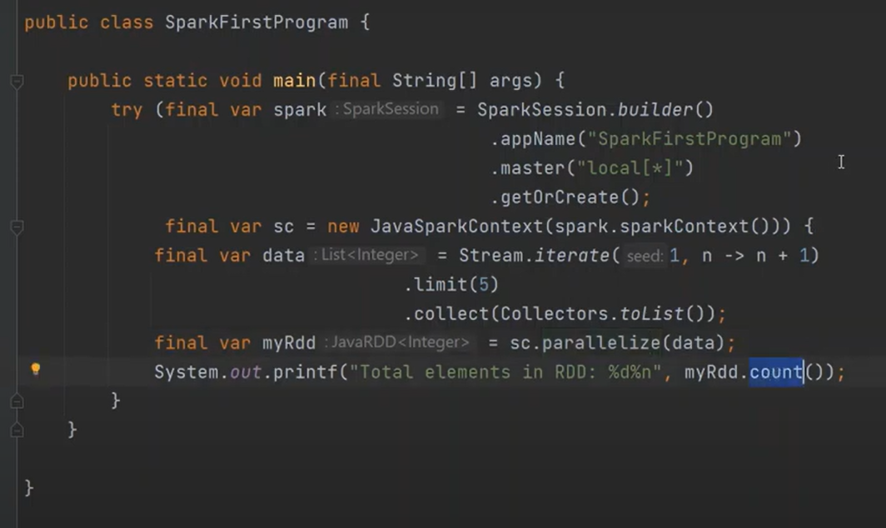

**SPARK RDD REDUCE METHODS**

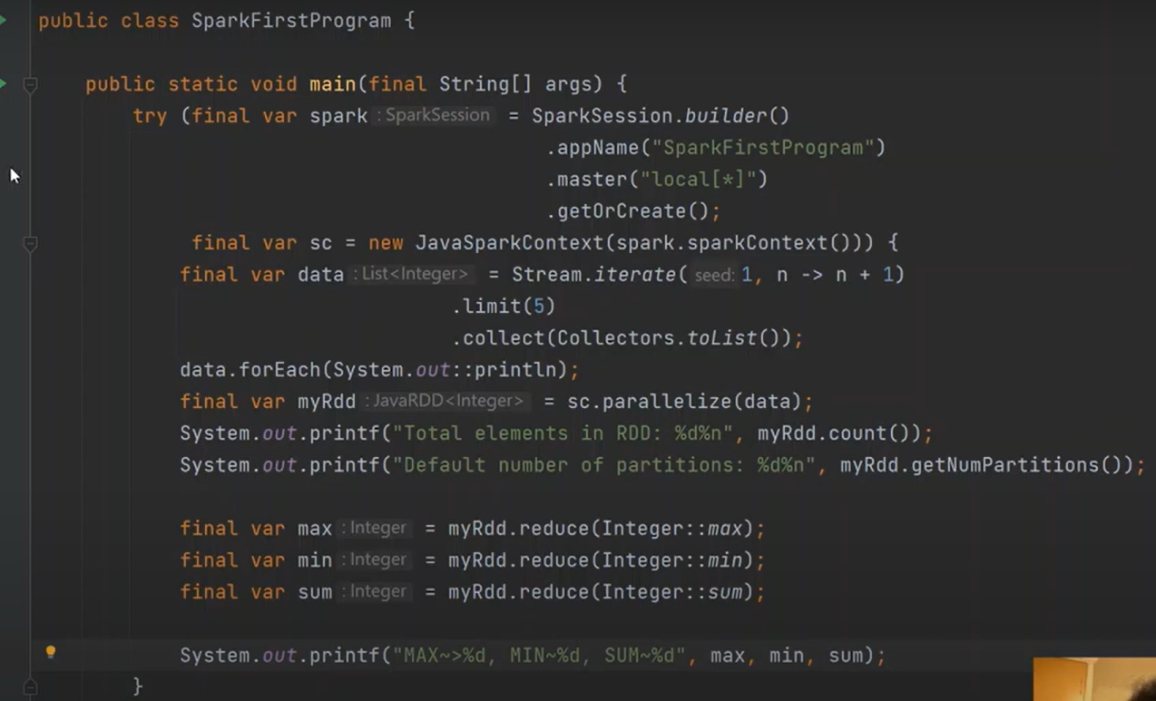

**SPARK WEB UI**

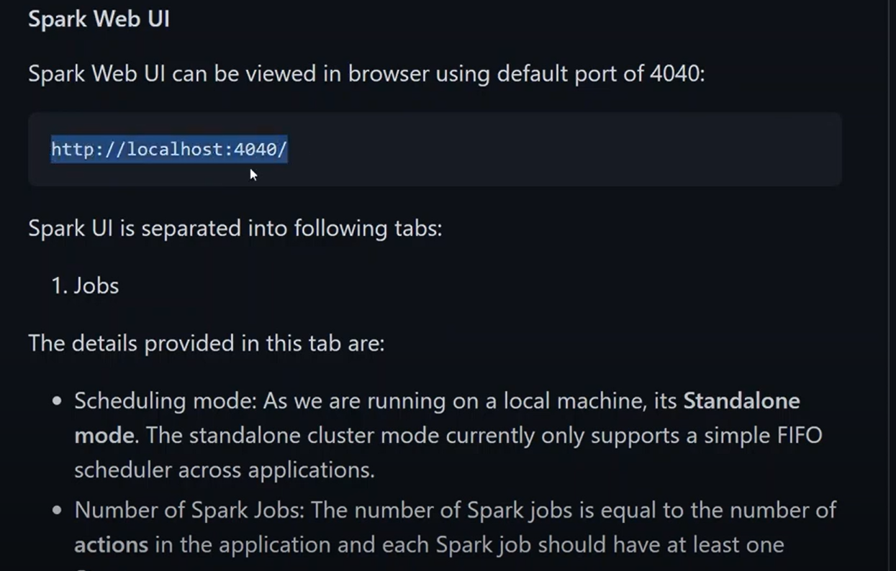

**CREATE RDD USING PARALLELIZE()**

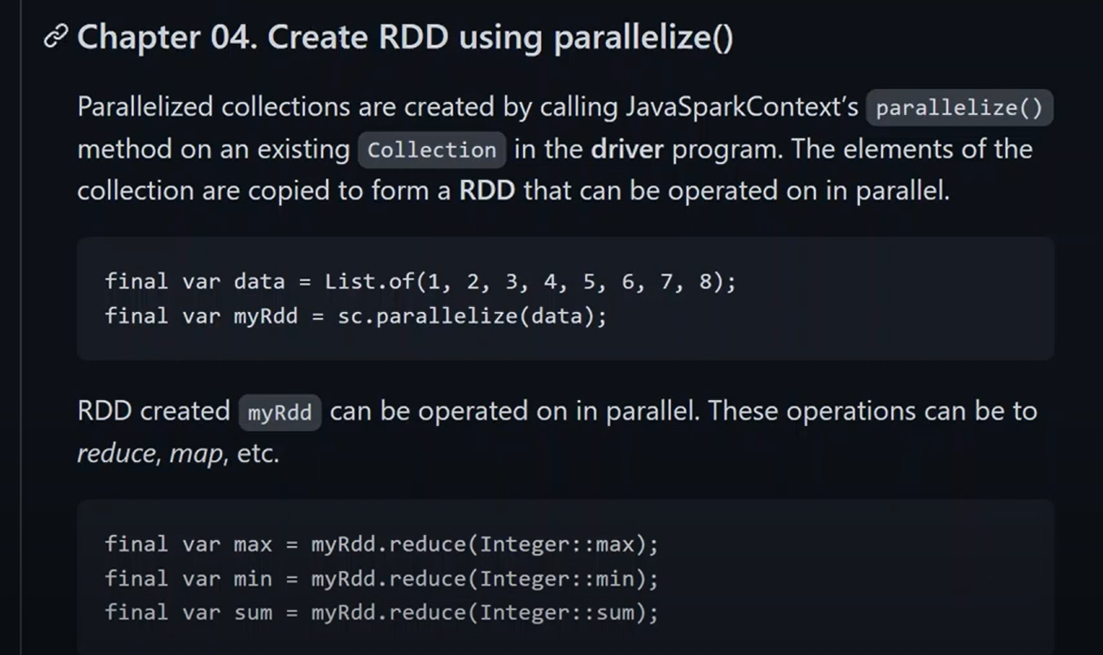

**SOME METHODS OF SPARK**

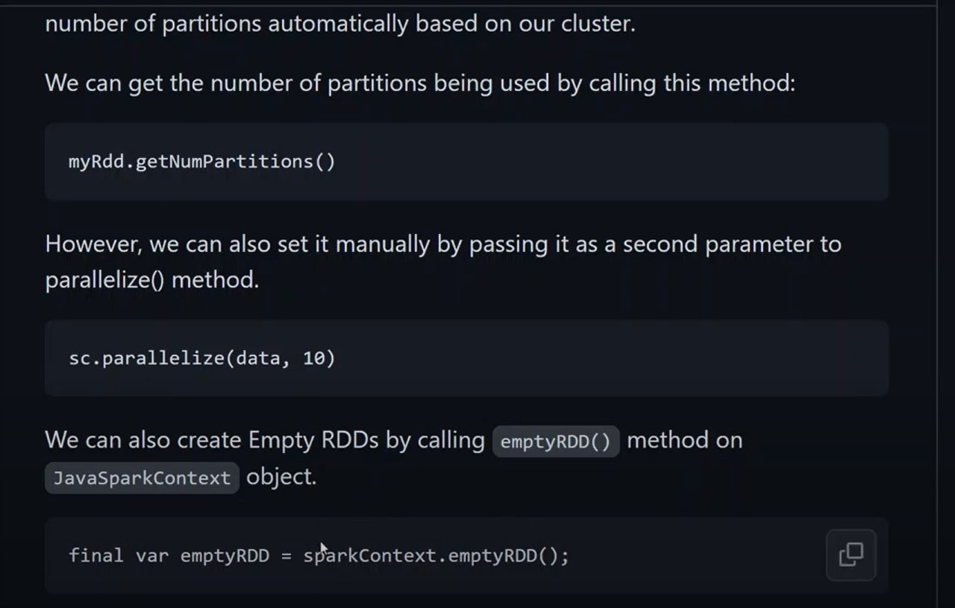

**Write rdd test case**

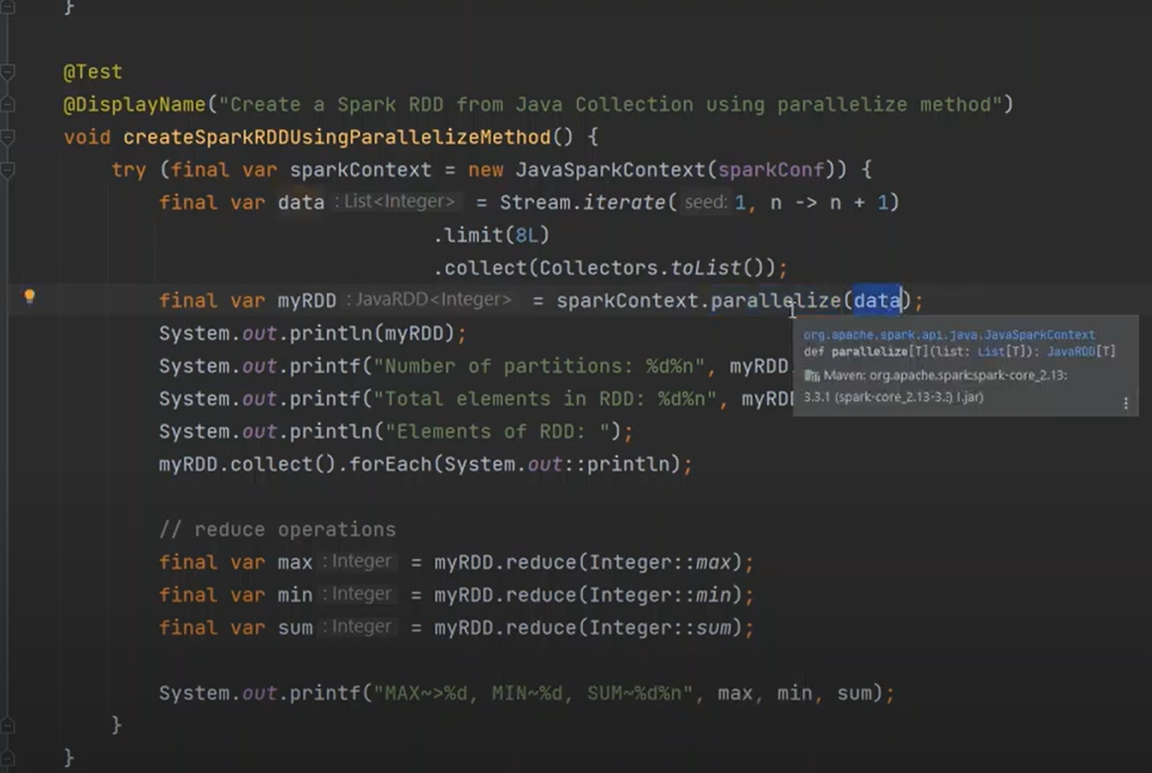

**CREATE SPARK RDD USING EXTERNAL DATA SOURCE**

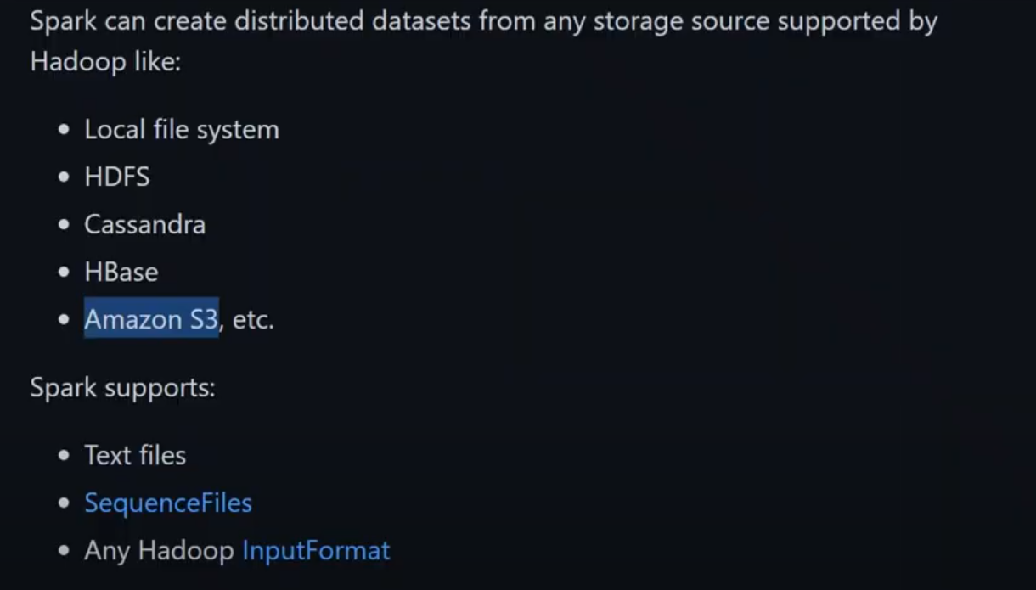

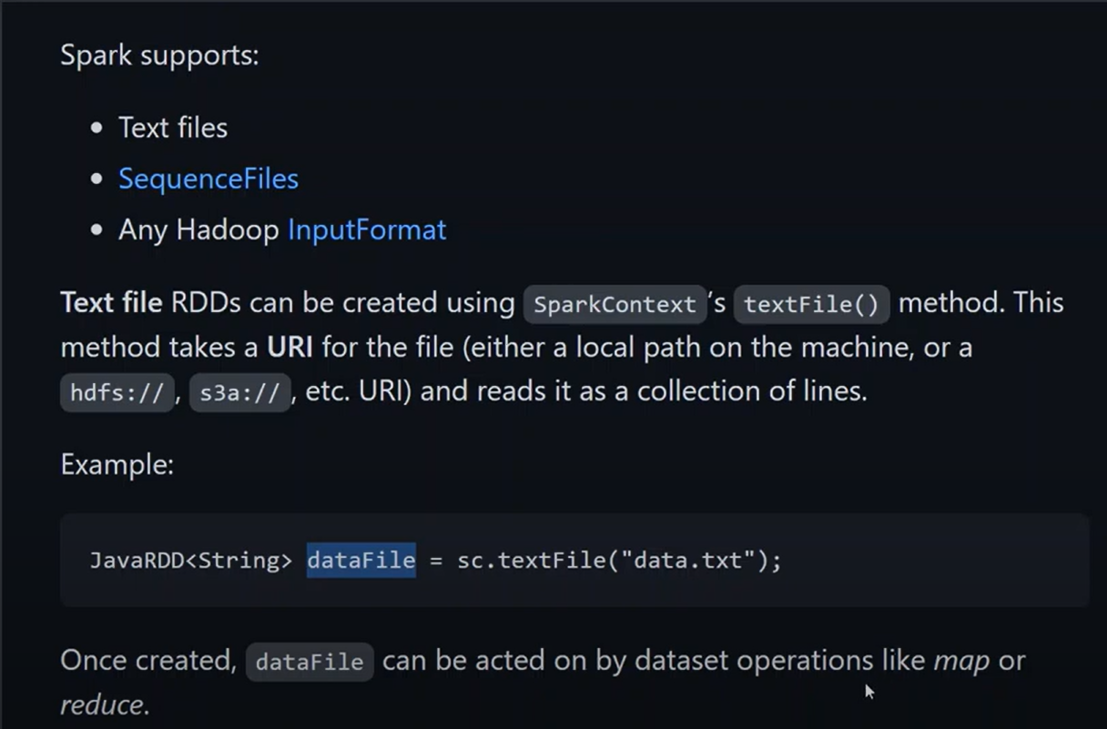

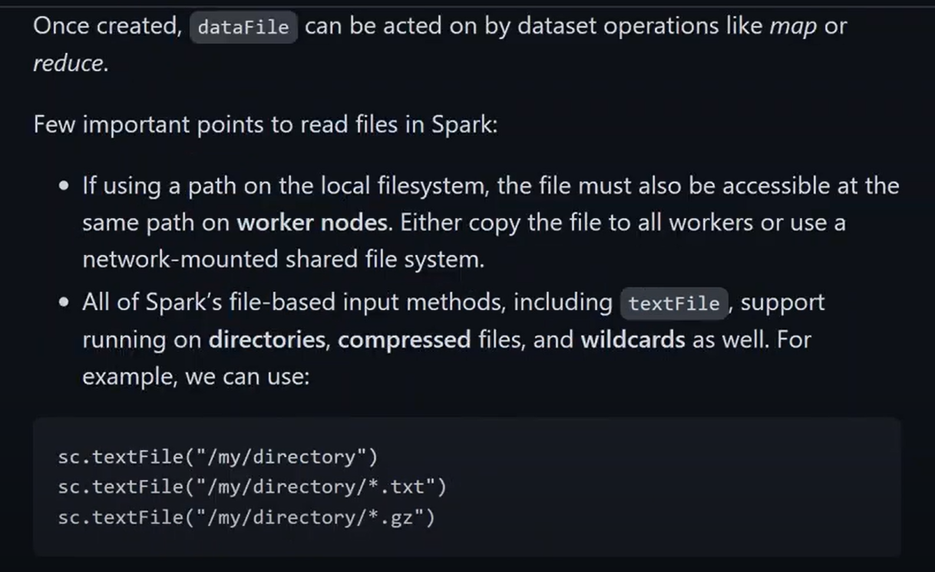

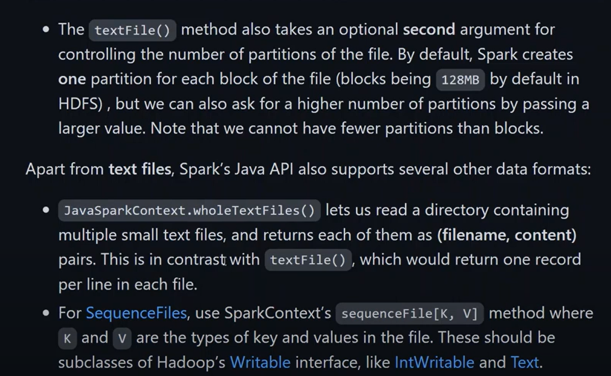

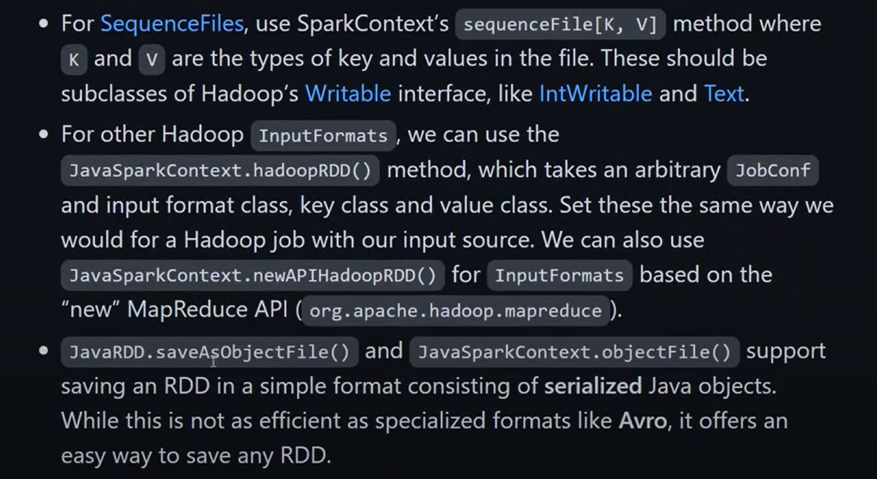

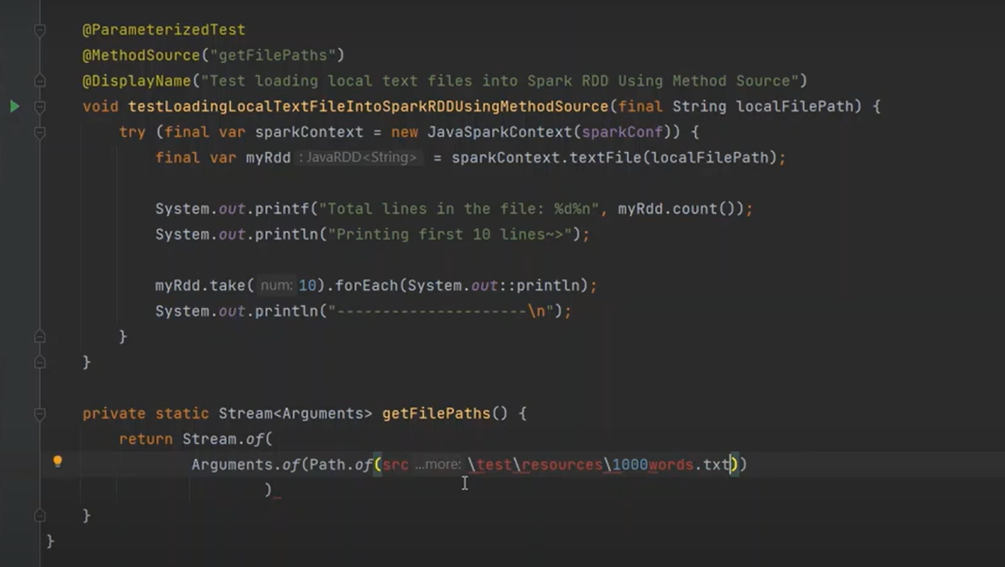

**CREATE SPARK RDD FROM WHOLE DIRECTORY**

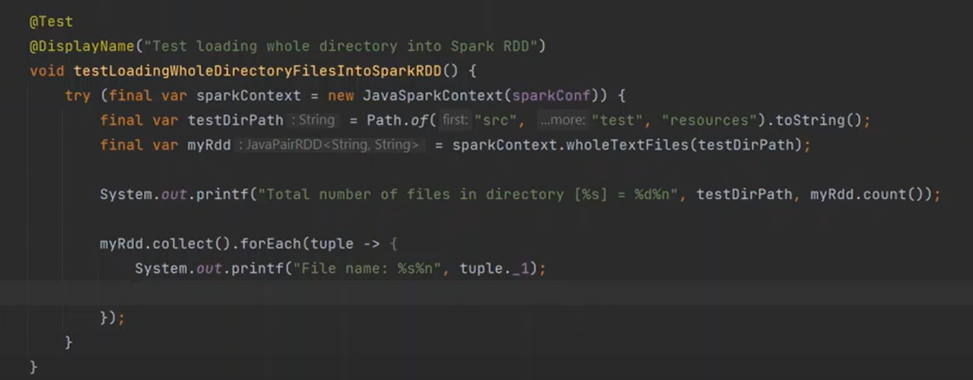

**CREATE SPARK RDD FROM CSV FILE**

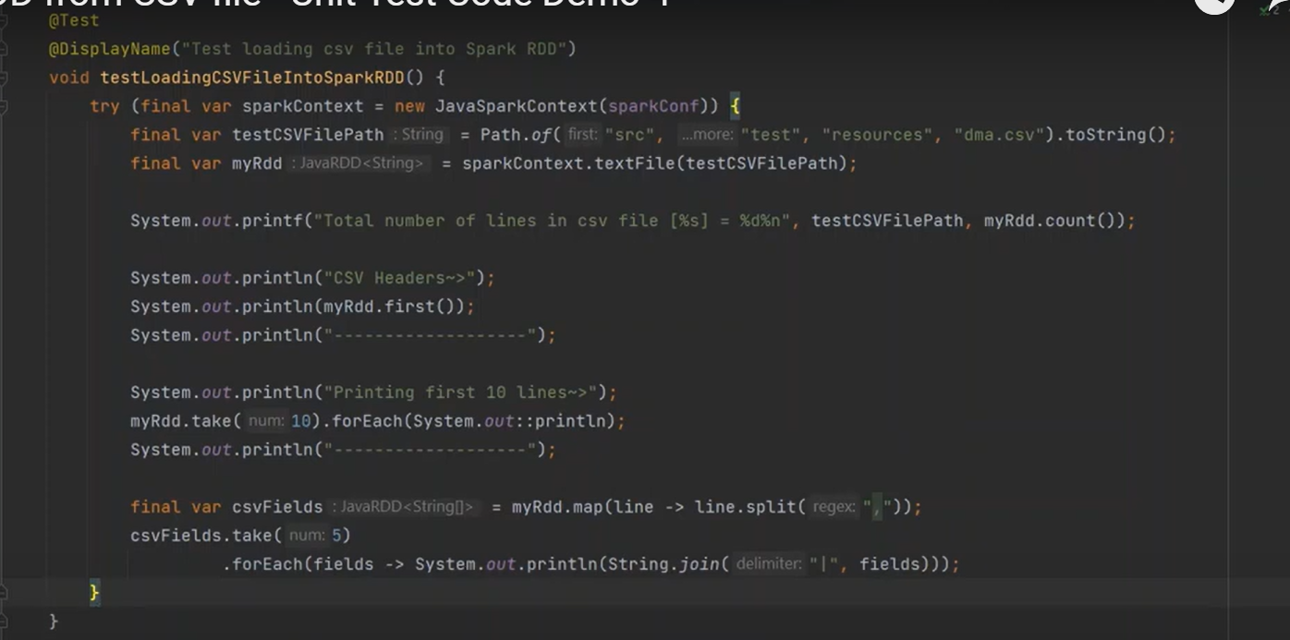

**CREATING RDD BY LOADING FILE FROM AWS S3 BUCKET**

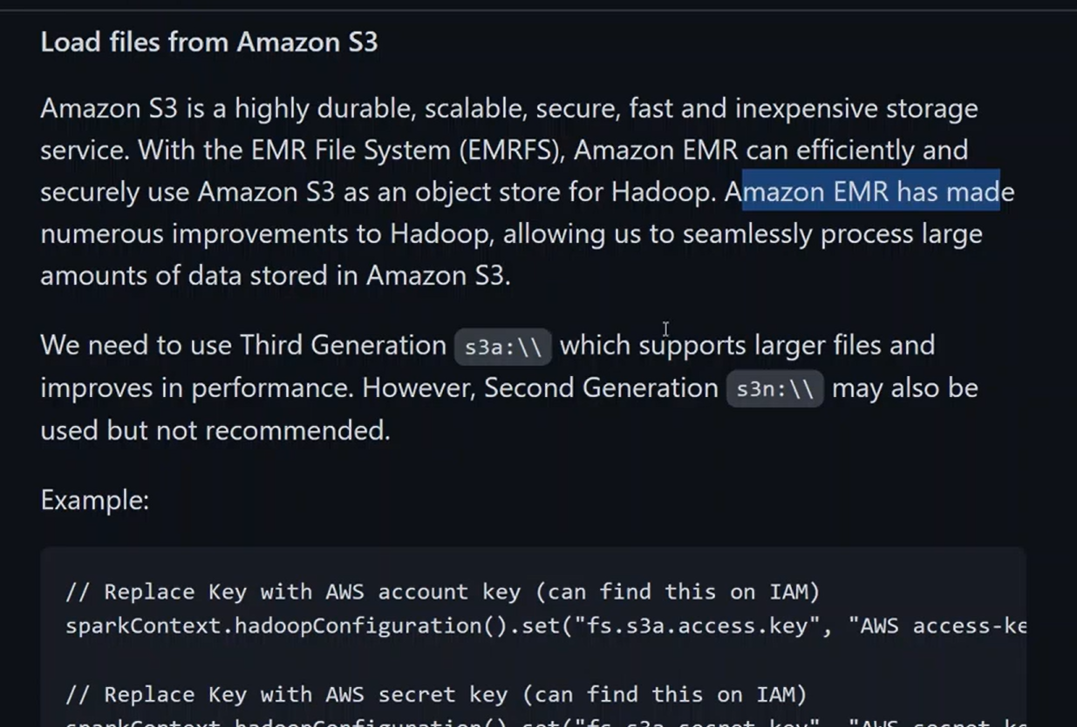

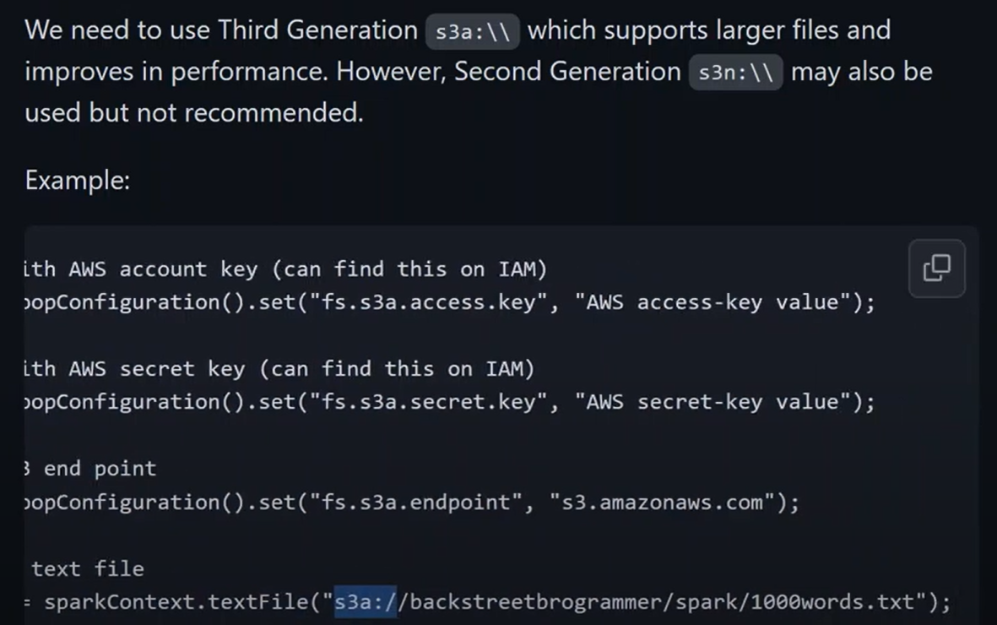

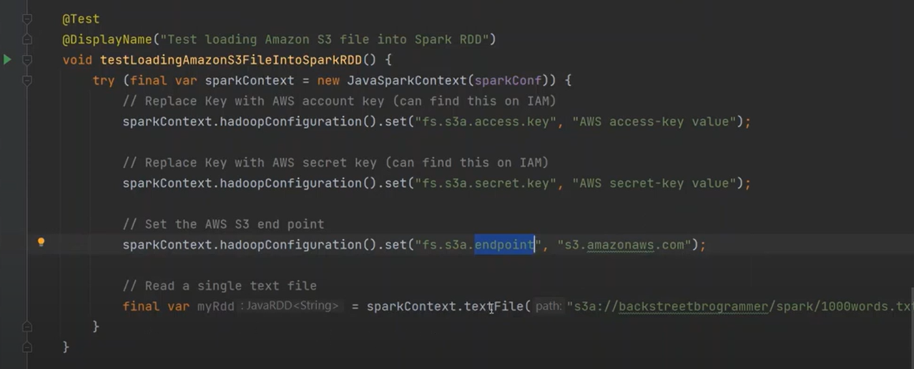

**SPARK RDD ACTIONS**

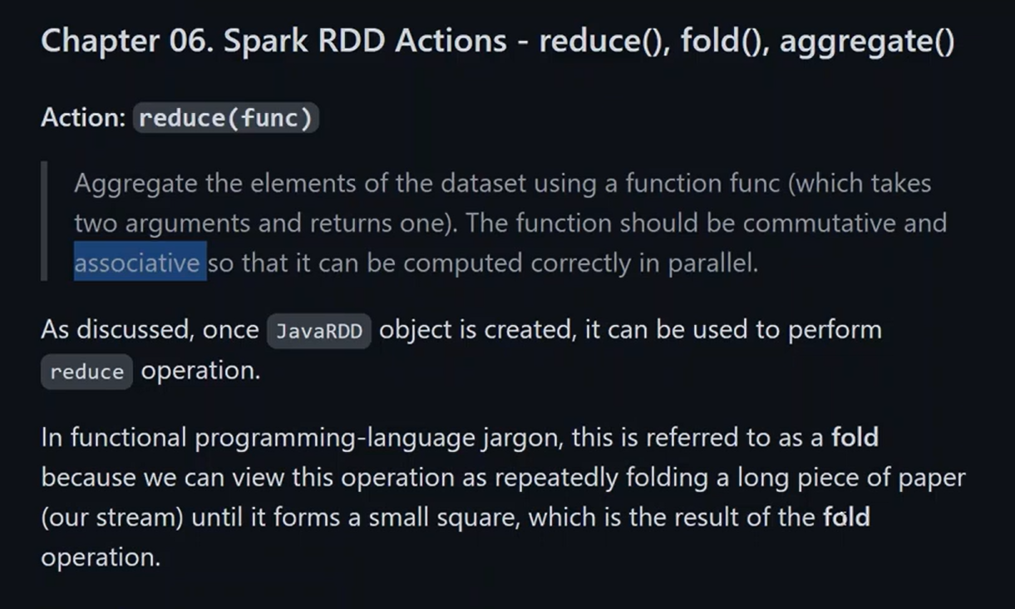

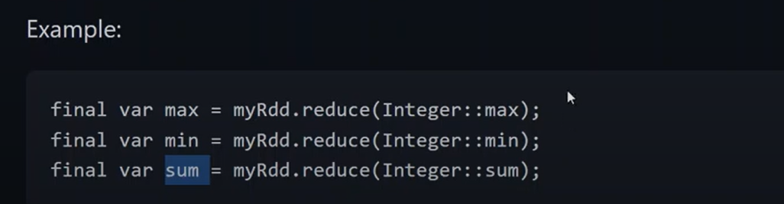

**Reduce**

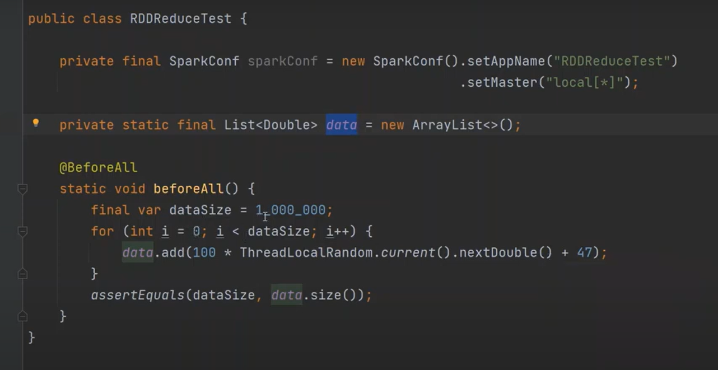

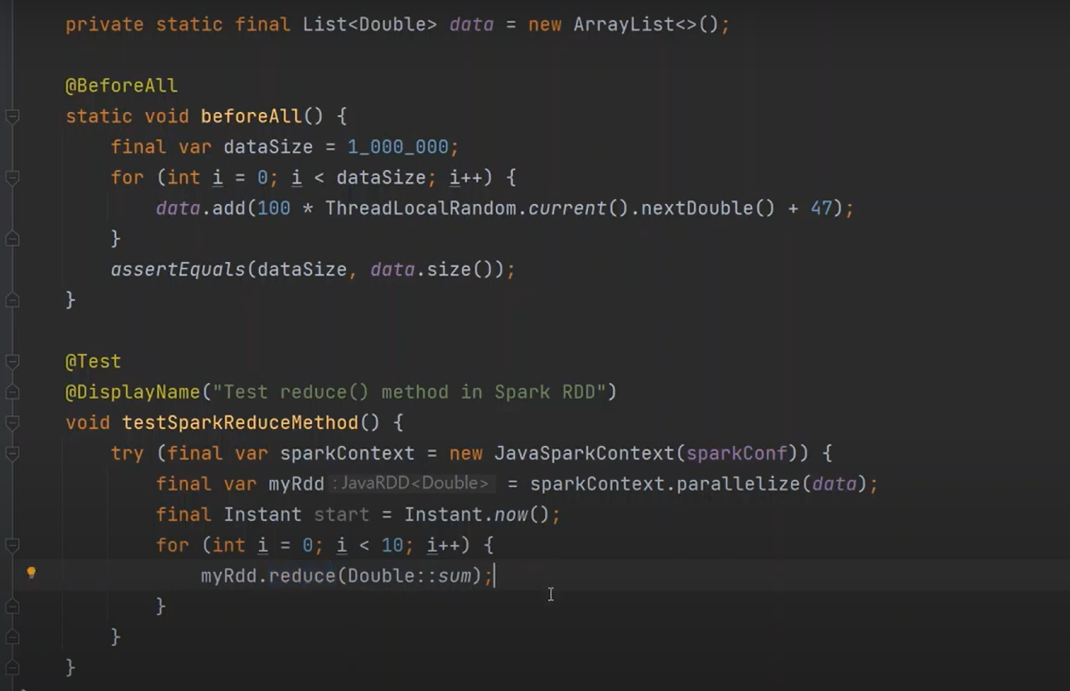

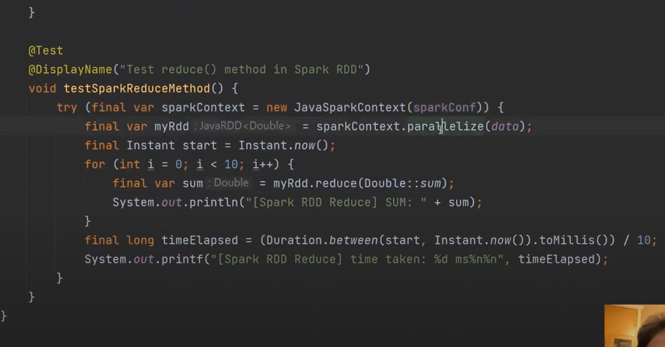

**Fold()**

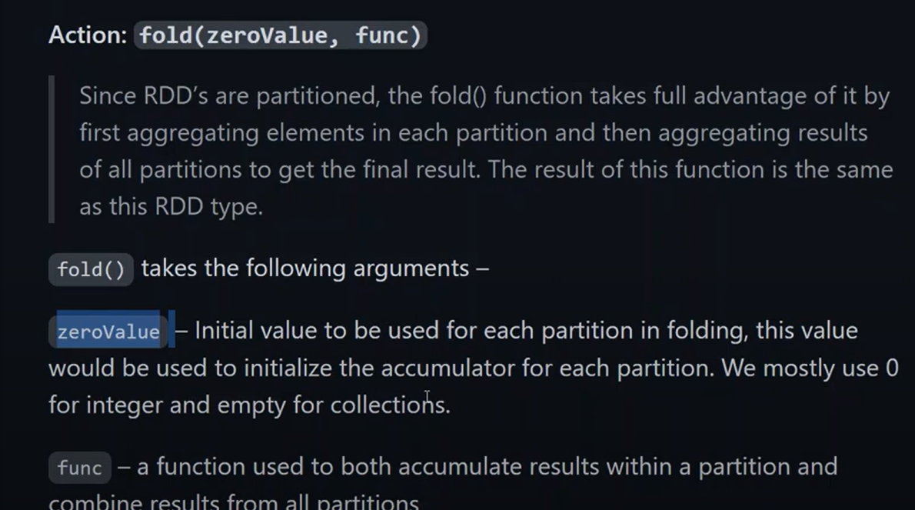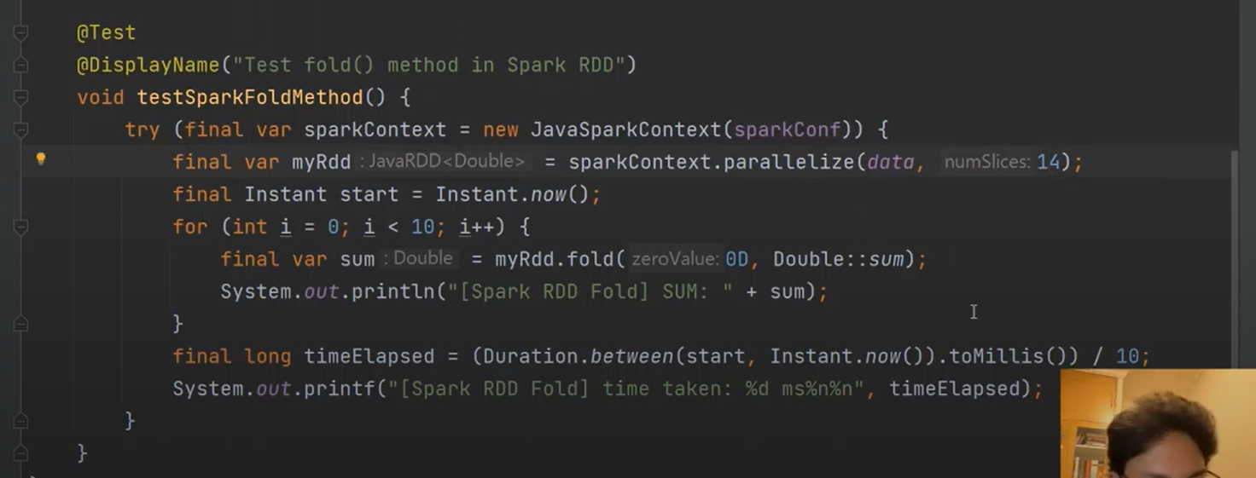

**Aggregate()**

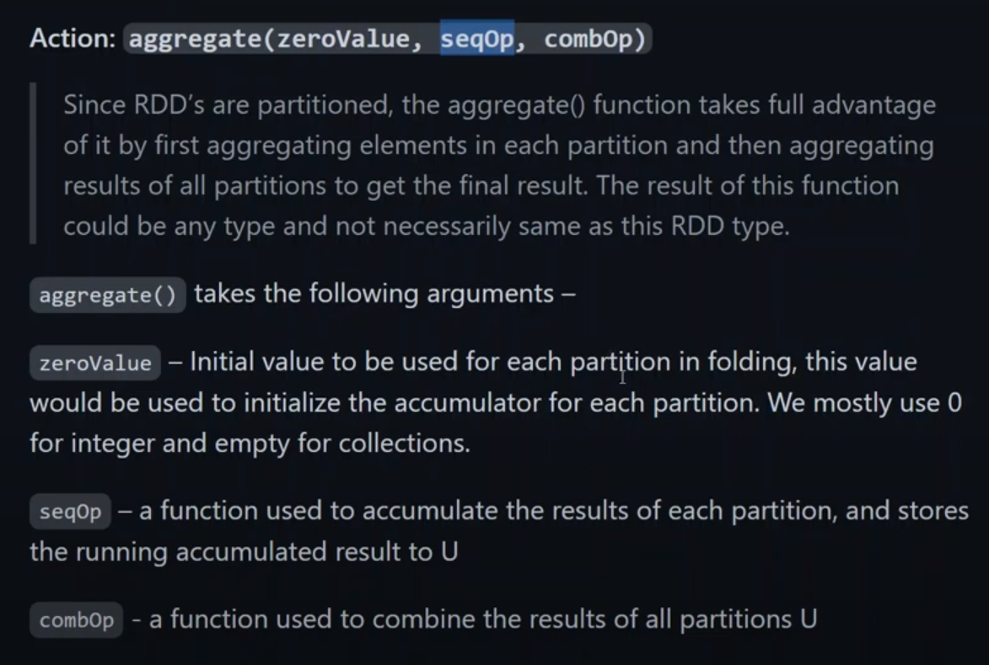

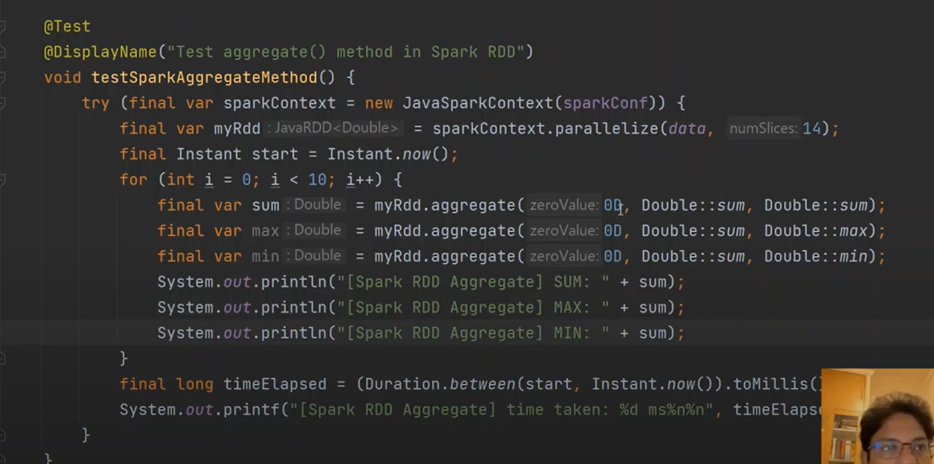

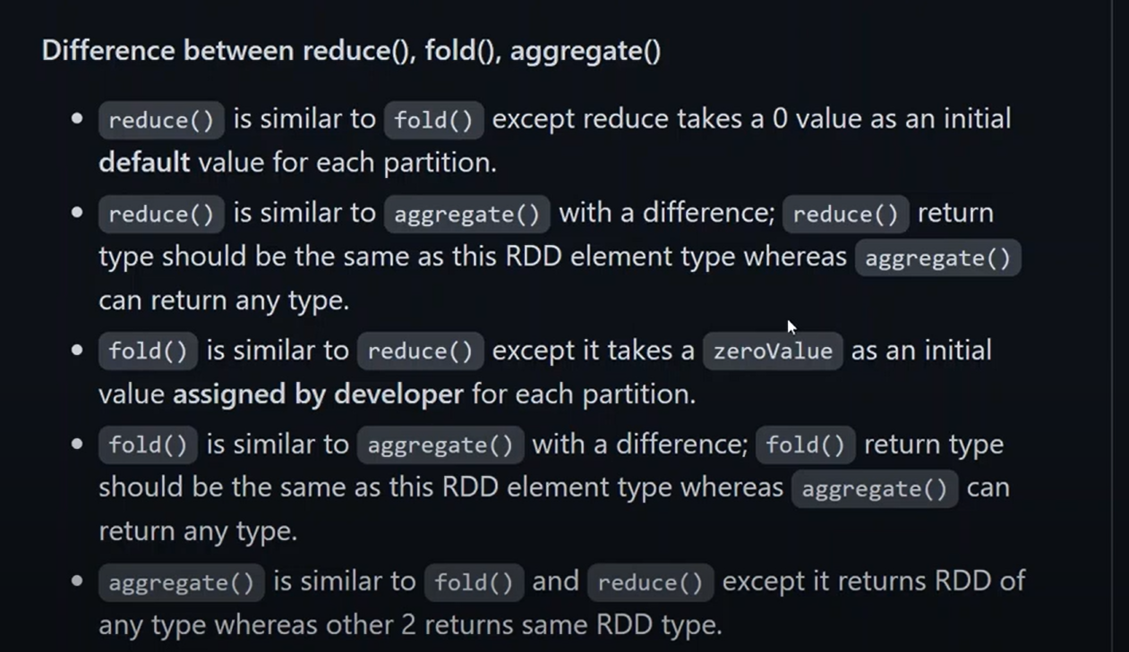

**Map(),flatMap() and filter()**

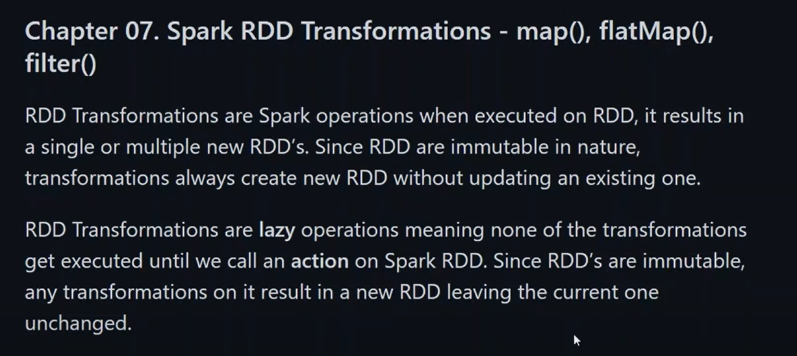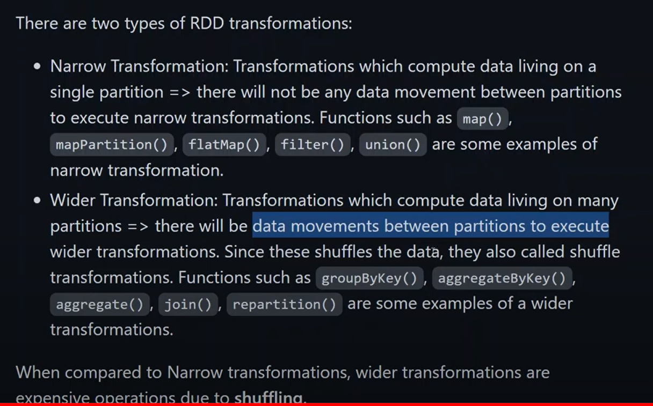

**Map() function rdd**

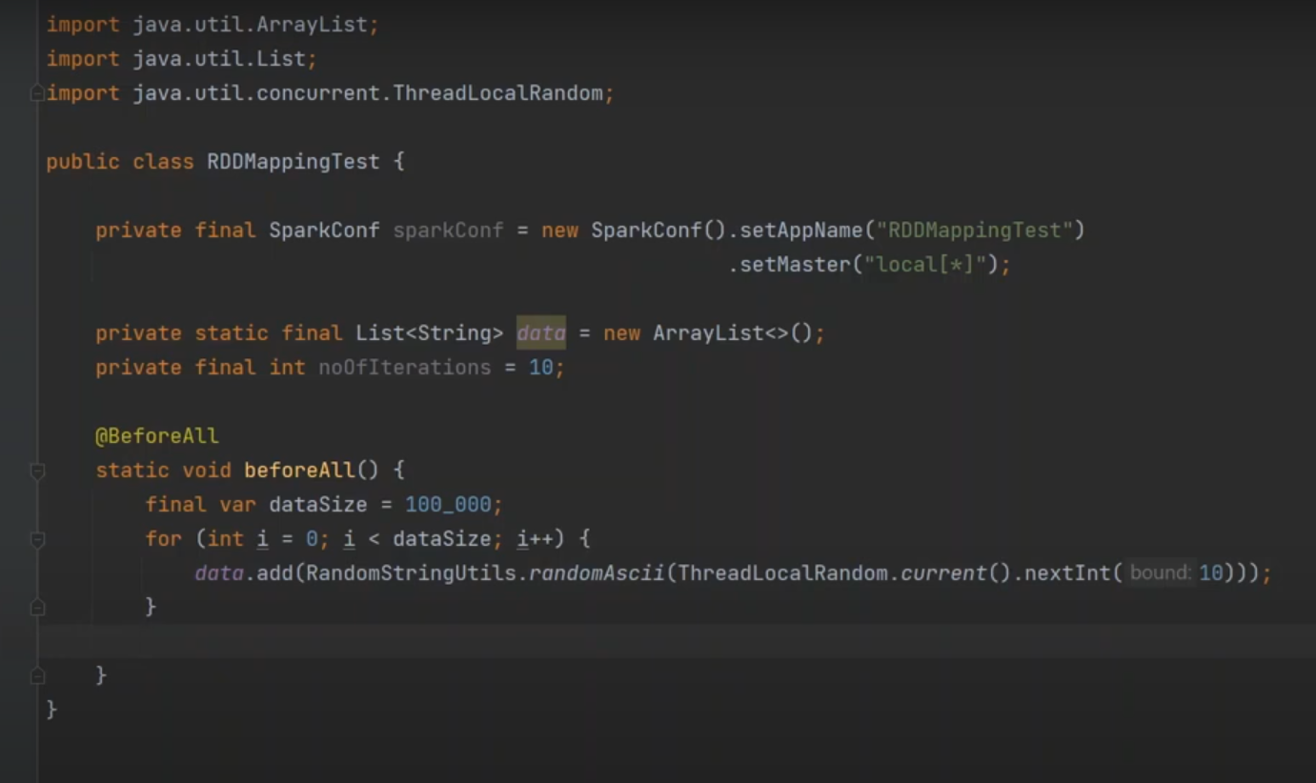

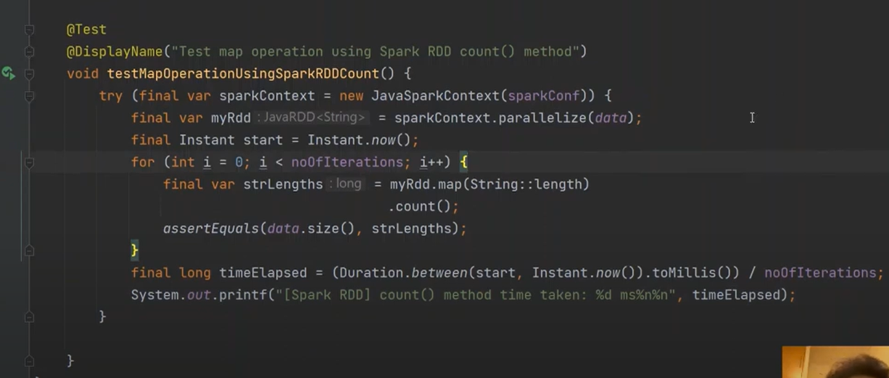

**Map() using reduce()**

